Project Design Phase-II
Data Flow Diagram & User Stories

Date | 15 February 2026
Team ID | LTVIP2026TMIDS65881
Project Name | DocSpot
Maximum Marks | 4 Marks

Data Flow Diagrams:
A Data Flow Diagram (DFD) illustrates how data moves within the Freelance Finder platform. It captures how users (freelancers and clients) interact with the system, how information flows between different components, and where the data is stored.
Example: DFD Level 0 (Industry Standard)

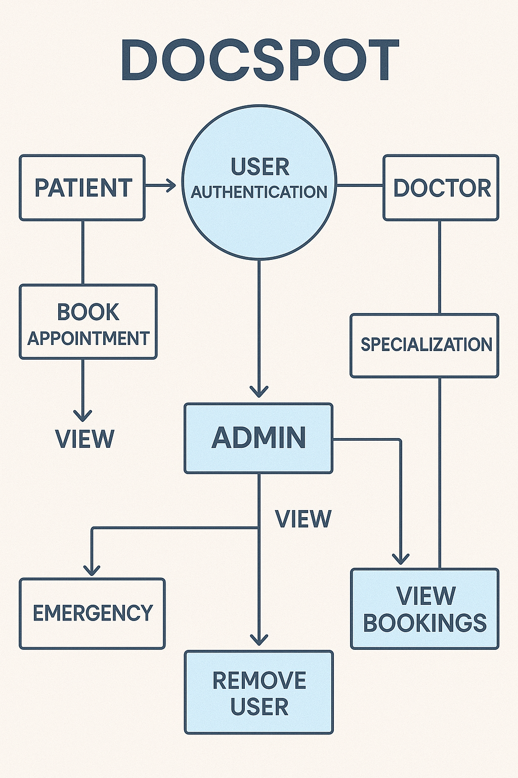

User Stories

User Story Table – DocSpot
User Type | Functional Requirement (Epic) | User Story / Task | Acceptance Criteria | Priority | Release
 |  | As a patient, I can search for doctors by specialty and location. | Search results return relevant doctors. | High | Sprint-1
  Patient
  Appointment Booking
 |  | As a patient, I can book, reschedule, or cancel appointments. |  | Medium | Sprint-2
  Appointment status updates accordingly.
 |  |  |  | High | Sprint-1
  Healthcare Provider
  Schedule Management
  As a provider, I can manage my availability calendar.
  Changes reflect immediately in patient booking system.
User | Messaging | As a user, I can chat with the other party in real-time. | Messages appear instantly. | Medium | Sprint-2
Admin | Profile Management | As a Admin, I can update my profile. | Changes are saved successfully. | High | Sprint-2
Client | Payment Processing | As a client, I can make secure payments after job completion. | Payment recorded and shown in transaction history. | High | Sprint-2
user |  | As a user, I can leave a review after project closure. | Review appears on profile. | Medium | Sprint-2
  Review System
Admin | User Moderation | As an admin, I can review reported users and take action. | Reports and actions logged. | High | Sprint-1

